|  |  |
| --- | --- |
| Name(s) | Morgan Daigle ,Damilola Osoba |

**Scoring Criteria Table: Provided at the Moodle submission site**

**Include images of your result displays below:** These must be screen shots. Pictures from your phone will not be evaluated and you will lose all points if phone images are used. These images should be clipped so that they show only the desired results as shown in the lab manual. Large portions of unnecessary image will lose you points. See the videos links posted for making screen shots or ask questions on how to do this. **Again - DO NOT USE Phone images**

Keep the item description as written below. Feel free to insert any comments you would like, especially if you did something above and beyond the requirements that you think should be considered for extra credit.

1. Insert a screen shot of the popup that allows the user to select the test they want to go with.

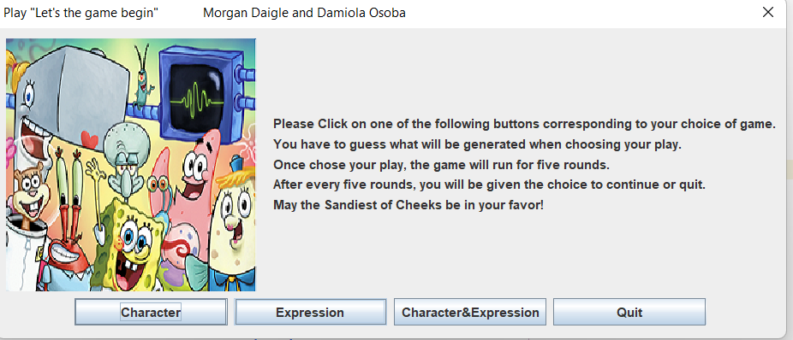

1. Insert a screen shot of the popup that allows the user to select a color in a color-only test.(Character*)

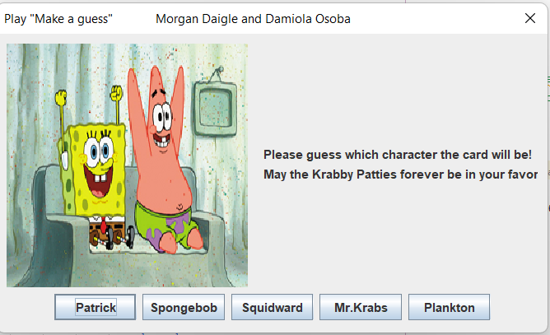

1. Insert a screen shot of the popup that allows the user to select a shape in a shape-only test.

(Expression*)

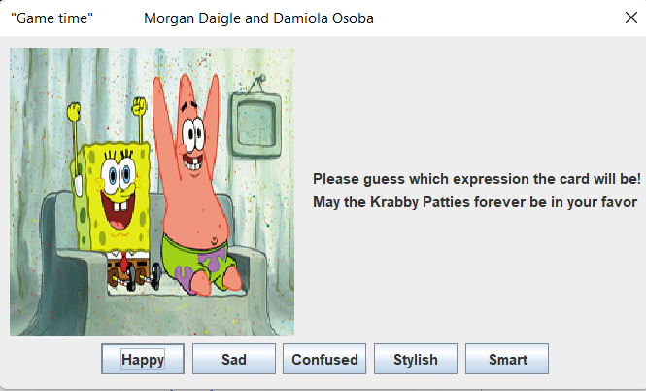

1. Insert a screen shot of the popup that shows the analysis of 5 trials for color-only test.

(Character*)

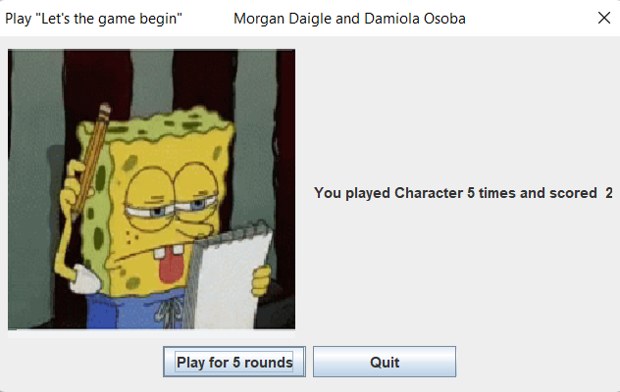

1. Insert a screen shot of the popup that shows the analysis of 5 trials for shape-only test.

(Expression*)

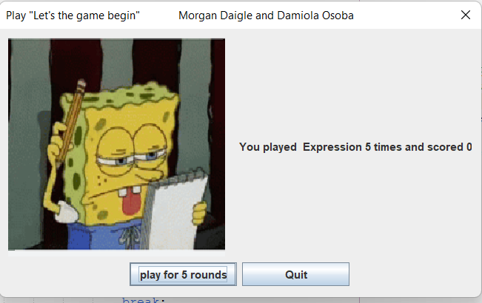

1. Insert a screen shot of the popup that shows the analysis of 5 trials for color and shape test.

(Character&Expression)

